**A short literature review on surface energies of amorphous silica, porous silica gel and porous glass:**

The surface tension, γ, of solids is expressed as a surface free energy called “Helmholtz Surface Free Energy”, F. The surface tension of a crystal face is related to the surface free energy by the relation “γ = F + A(dF/dA)”, where A is the area of the surface 1.

An early study showed that the surface energy of a soda lime silicate glass measured using Sessile drop method at ambient conditions is around **83.4 mJ/m2**. This value is close to the surface energy of water at 20°C. Therefore, the authors suggested that this indicates the presence of adsorbed water molecules on the glass surface. Studies conducted on baked glass (heat treatment at 500°C) to remove adsorbed water molecules suggest that the surface energy of glass may be around **230 mJ/m2** 2.

The total surface energy of a surface is a sum of two components: the dispersive component and the specific component resulting from polar interactions. The surface energy can be either calculated using equations, for example the Gibbs-Thomson equation, or they can be measured, most popularly using Inverse Gas Chromatography, Sessile drop method etc.

Table 1 (at the end of the note) presents a collection of surface energy values from literature (3–11). These values have been mostly collected from literature studying the amorphous silica systems, porous silica gels and porous glasses. The more recent publications presenting the dispersive surface energy values of silica gel measured using Gas chromatography techniques show an average value around 50 mJ/m2. The silica gel used in these studies had different porosities and surface properties. The dispersive surface energy is affected by the morphology of the silica gel, but the correlation is not clear in certain studies (see Figure 1). However, there was a clear correlation between the surface OH- concentration and the surface energy in another study (see Figure 2) and even between the pore size and the surface energy. The silica gel with four nm pore size exhibited significantly higher dispersive surface energy than the silica gel with eight nm pore size 6. It should be mentioned that the silica gel was treated with 1,1,1,3,3,3-hexamethyldisilazane (HMDS) or 3-amino-propyltriethoxysilane (3-APTS) to alter the surface morphology and include OH- groups in the surface6.



Figure 1 The dispersive surface energy as a function of the surface area and pore size distribution of the studied silica gels5



Silica gel with pore size of 4 nm or 8 nm

Porous glass

Figure 2 Dispersive surface energy as a function of the OH- concentration in the surface6

Some studies conducted on porous glasses with controlled porosity (porous glass may contain 94-99% SiO2, 1-6% B2O3 and up to 0.5% Na2O) show a very clear correlation between the pore sizes of the glass and the total surface energy (see Figure 3) 10. The study on porous glasses by Bilinsky et al. 7–10 present the value of both the components of the surface energy, i.e. the dispersive energy and the specific energy. As can be seen from Table 1, the specific component of the surface energy is significantly higher and more influenced by pore size, at least in one study 9. For the silica gels, one study gives the values of the specific surface energy as well. However, in this case, the specific surface energy values are lower than that of the dispersive free energies 5. Bilinsky et al. also give the specific surface energy values for some silica gels 8. However, the values are higher than that of the dispersive surface energy values for the pure silica gel. As the silica gel is thermally treated to incorporate B and Na species in the surface, the specific surface energy significantly decreases, whereas the dispersive surface energy seems to be affected less significantly.

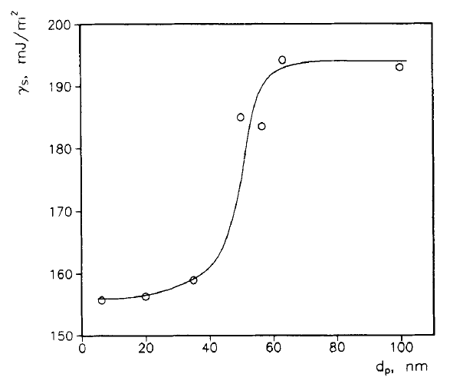

Figure 3 The total surface energy of porous glasses as a function of their pore sizes10

An earlier study presented the calculated total surface energy values of amorphous silica and hydrated amorphous silica 3. This study suggested a value of **259 mJ/m2** for pure siloxane surface, which is closer to the value discussed earlier (**230 mJ/m2**) in another study 2. Hydrated amorphous silica had significantly lower calculated total surface energy (**129 mJ/m2**). This is in agreement with the conclusions presented earlier that surface OH- groups decrease the surface energy. Figure 4 demonstrates how the surface free energy of quartz changes as a function of interaction with water 12. The surface free energy values of quartz are much higher than that of amorphous silica.

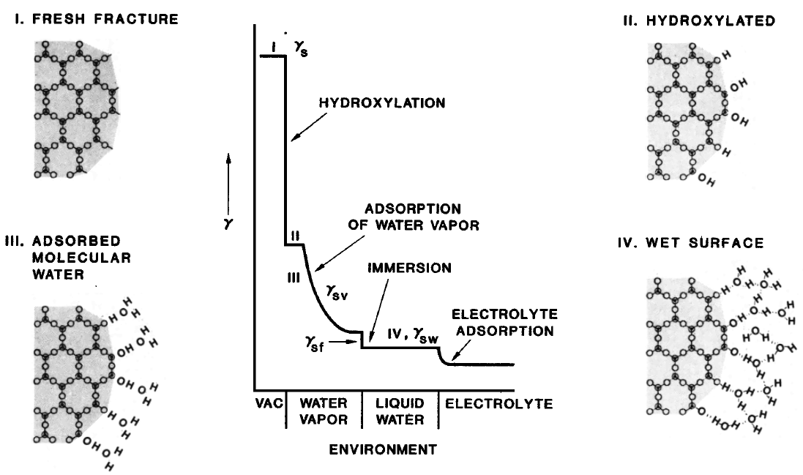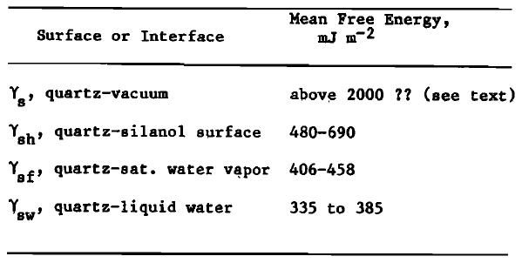

Figure 4 Schematic description of the relation between the surface energy and the interaction between quartz and water12

**Molecular Dynamics (MD) simulations of amorphous silica surfaces:**

MD simulations were used to study the equilibrium properties of the surface of amorphous silica 13. Two types of geometries were used: clusters of 13.5, 19 and 26.5 Å, and, a thin film with thickness of 29 Å (bulk). The surface energy is in “qualitative” agreement with the experimental value for the surface tension (**330 mJ/m2**). The BKS potential was used to simulate the amorphous silica.

The clusters also include the surface energy S. ε is the surface energy per unit area and not the same as the surface tension σ. Due to the entropic contribution to the free energy, ε ≥ σ. The calculated surface energy is ε = 0.7±0.1 N/m. i.e. approximately **700 mJ/m2**. Based on the comparison of various properties between the clusters and the thin film, the authors have concluded that the curvature of the surface in the surface geometry is irrelevant 13.

In another study, MD simulation of amorphous spherical SiO2 nano particles of sizes of 2, 4 and 6 nm were performed. The pair interatomic potentials were used which have weak Coulomb interaction and Morse type short-range interaction. The surface energy ranges from **142 to 100m J/m2** over the temperature range from 7000 to 350 K 14.

**A few studies on the surface tension of water in silica pores or interfacial tension at the pore wall:**

In a study on the changes in density and surface tension of water in silica pores 15, it was shown that the surface tension of water in pores is smaller than the bulk liquid, notably for pore sizes <5 nm. The surface tension decreased with a decrease in pore size. It is also decreased with an increase in the surface hydroxyl groups’ concentration. The study was conducted on porous silica glass and MCM-41 silica gel of ordered mesoporous structure. Up to 4 nm thickness of adsorbed water molecules, there is a strong change in water structure and therefore, the surface tension as well. When the surface affinity for water molecules decreases, the effect of pore-size on the surface tension decreases. The surface tension decreases by a factor of 30% in pore sizes <2 nm due to the change in the mean radius of curvature of the meniscus15. The decrease in surface tension of water in pores compared to bulk water has been also reported by other publications 16. A few studies consider the solid/liquid interfacial surface tension, whose value in the bulk was reported to be 31.7 mJ/m2 16. Other studies use the ratio of the interfacial surface tension of water - vacuum, and the difference between the interfacial surface tension of silica - water with the surface tension of silica – vacuum to get information about the hydrophobic or the hydrophilic nature of the silica surface 17.

Table 1 Surface energy values reported in literature

|  |  |  |  |  |  |  |
| --- | --- | --- | --- | --- | --- | --- |
| **Reference** | **Surface energy measured on** | **Measured using** | **Material** | **Probe medium** | **Dispersive surface energy value, mJ/m2** | **Non-Dispersive component surface energy value, mJ/m2** |
| Brunauer, S., Kantro, D. L. & Weise, C. H. The surface energies of amorphous silica and hydrous amorphous silica. Can. J. Chem. 34, 1483–1496 (1956).3 | Amorphous silica of zero water content (pure siloxane surface) | Calculated using equations after measuring heat of hydration, heat of solution, average bound water content and the average specific surface area | high purity silica gel (specific surface area varying from 380-720 m2/g | - | 259 | |
| Surface energy of hydrous amorphous silica with a completely hydrated surface (pure silanol surface) | 129 | |
| Mizele, J., Dandurand, J. L. & Schott, J. Determination of the surface energy of amorphous silica from solubility measurements in micropores. Surf. Sci. 162, 830–837 (1985).4 | Pastes with 21-25 % amorphous silica and 75-79 % aqueous solution containing dissolved silica. Two types of solution were used: pure water and NaCl (0.7 - 1M) | Calculated using equations after studying the solubility of amorphpous silica at 20 °C as a function of pore size using a pressure membrane extractor | Amorphous hydrated silica gel of specific surface area of 370 m2/g | In pure water | 340 | |
| in NaCl solutions | 510 | |
| Palash, M. L., Pal, A., Rupam, T. H., Park, B.-D. & Saha, B. B. Surface energy characterization of different particulate silica gels at infinite dilution. Colloids Surf. Physicochem. Eng. Asp. 603, 125209 (2020).5 | 4 types of silica gel with different pore characteristics | Inverse gas chromatography | Home silica gel | Different polar and non-polar organic solvents | 60 | 15 |
| Chromatorex silica gel | 50 | 10 |
| B-type silica gel | 40 | 14 |
| RD granular silica gel | 90 | 18.5 |
| Rückriem, M. et al. Inverse gas chromatography for determining the dispersive surface energy of porous silica. Colloids Surf. Physicochem. Eng. Asp. 357, 21–26 (2010).6 | Mesoporous glass beads, commercial silica gels with 4 nm, 8 nm and 15 nm mean pore diameter, MCM-41, SBA-15, SBA-16 | Inverse gas chromatography | Porous glass | Organic solvents | 40 |  |
| SG4 | 52 |  |
| SG8 | 40 |  |
| SG15 | 48 |  |
| MCM-41 | 51.61 |  |
| SBA-15 | 56.03 |  |
| SBA-16 | 71.93 |  |
| Biliński, B., Wójcik, W. & Dawidowicz, A. L. Investigation of the surface free energy components of thermally treated controlled porosity glasses by inverse gas chromatography. Appl. Surf. Sci. 47, 99–108 (1991).8 | Controlled porous glass (CPG), and CPG heat treated for different durations (CPG2, CPG20 and CPG120) and silica gel, silica gel dehydroxylated, silica gel treated to have B and Na species in the pore surface | Gas chromatography, adsorption isotherms and mathematical calculations | CPG | n-Octane (for dispersive)/Toluene (for non-dispersive) | 37.3 | 144.7 |
| CPG2 | 40.2 | 55.8 |
| CPG20 | 39.5 | 37.5 |
| CPG120 | 36.8 | 37.4 |
| SG | 35.6 | 159.8 |
| SGD | 39.1 | 105.8 |
| SG/B | 37.3 | 37.5 |
| SG/Na, B | 43 | 53.8 |
| Biliński, B. & Dawidowicz, A. L. Correlation between surface free energy and porosity of controlled-porosity glasses. Colloids Surf. Physicochem. Eng. Asp. 70, 61–67 (1993).9 | CPG of changing porosity (from 6 nm to 100 nm) | Gas chromatography, adsorption isotherms and mathematical calculations | CPG1 | n-Octane (for dispersive)/Toluene (for non-dispersive) | 42 | 113.7 |
| CPG2 | 34 | 122.3 |
| CPG3 | 34.1 | 124.8 |
| CPG4 | 35.8 | 147.7 |
| CPG5 | 35 | 159.2 |
| CPG6 | 37.3 | 147.7 |
| CPG7 | 35.7 | 157.3 |
| Rueckriem, M., Hahn, T. & Enke, D. Inverse gas chromatographic studies on porous glass.11 | Porous glasses of varying properties | Inverse gas chromatography | PG1 (mean pore diameter 11 nm) | 6 different organic solvents including n-Octane | 40.63 |  |
| PG2 (mean pore diameter 21 nm) | 45.45 |  |
| PG3 (mean pore diameter 53 nm) | 50.76 |  |

References :

1. Shuttleworth, R. The Surface Tension of Solids. *Proceedings of the Physical Society. Section A* **63**, 444 (1950).

2. Rhee, S. K. Surface energies of silicate glasses calculated from their wettability data. *J Mater Sci* **12**, 823–824 (1977).

3. Brunauer, S., Kantro, D. L. & Weise, C. H. The surface energies of amorphous silica and hydrous amorphous silica. *Can. J. Chem.* **34**, 1483–1496 (1956).

4. Mizele, J., Dandurand, J. L. & Schott, J. Determination of the surface energy of amorphous silica from solubility measurements in micropores. *Surface Science* **162**, 830–837 (1985).

5. Palash, M. L., Pal, A., Rupam, T. H., Park, B.-D. & Saha, B. B. Surface energy characterization of different particulate silica gels at infinite dilution. *Colloids and Surfaces A: Physicochemical and Engineering Aspects* **603**, 125209 (2020).

6. Rückriem, M. *et al.* Inverse gas chromatography for determining the dispersive surface energy of porous silica. *Colloids and Surfaces A: Physicochemical and Engineering Aspects* **357**, 21–26 (2010).

7. Biliński, B. & Dawidowicz, A. L. Investigation of porous structure and surface properties of controlled porosity glasses. *Colloids and Surfaces A: Physicochemical and Engineering Aspects* **118**, 149–160 (1996).

8. Biliński, B., Wójcik, W. & Dawidowicz, A. L. Investigation of the surface free energy components of thermally treated controlled porosity glasses by inverse gas chromatography. *Applied Surface Science* **47**, 99–108 (1991).

9. Biliński, B. & Dawidowicz, A. L. Correlation between surface free energy and porosity of controlled-porosity glasses. *Colloids and Surfaces A: Physicochemical and Engineering Aspects* **70**, 61–67 (1993).

10. Biliński, B., Wójcik, W. & Dawidowicz, A. The surface properties of controlled porosity glasses of various porosity. in *Trends in Colloid and Interface Science VIII* (eds. Ottewill, R. H. & Rennie, A. R.) 46–50 (Steinkopff, 1994). doi:10.1007/BFb0115134.

11. Rueckriem, M., Hahn, T. & Enke, D. Inverse gas chromatographic studies on porous glass.

12. Parks, G. A. Surface and interfacial free energies of quartz. *Journal of Geophysical Research: Solid Earth* **89**, 3997–4008 (1984).

13. Roder, A., Kob, W. & Binder, K. Structure and dynamics of amorphous silica surfaces. *J. Chem. Phys.* **114**, 7602–7614 (2001).

14. Hoang, V. V. Molecular Dynamics Simulation of Amorphous SiO2 Nanoparticles. *J. Phys. Chem. B* **111**, 12649–12656 (2007).

15. Takei, T. *et al.* Changes in density and surface tension of water in silica pores. *Colloid Polym Sci* **278**, 475–480 (2000).

16. Knight, A. W., Kalugin, N. G., Coker, E. & Ilgen, A. G. Water properties under nano-scale confinement. *Sci Rep* **9**, 8246 (2019).

17. Pafong, E., Geske, J. & Drossel, B. On the influence of the intermolecular potential on the wetting properties of water on silica surfaces. *J. Chem. Phys.* **145**, 114901 (2016).